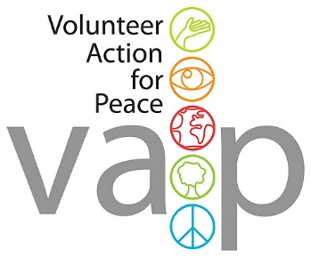


GB-IVS 12.2
1 to 19 June 2026

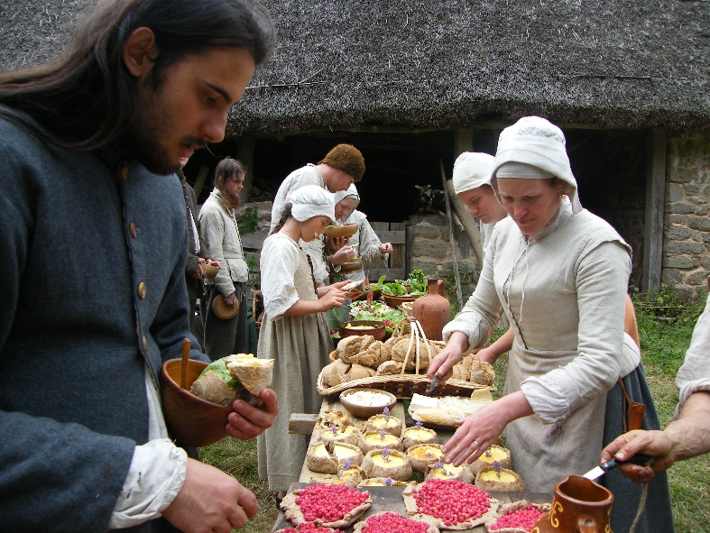
Grayhill Living History Camp

INFORMATION SHEET

Contact Information

Hosting Organisation:
International Voluntary Service / Volunteer Action for Peace
Thorn House, 5 Rose Street, Edinburgh, EH2 2PR, Scotland, UK
Email: action@vap.org.uk / info@ivsgb.org
Web: www.ivsgb.org

Contact person:
Nuno Doria, Programme Manager

Hosting Project:
Grayhill Farm
Llainvair Discoed
Chepstow LP16 6LZ, Wales, UK

Contact person:
Stuart Peachey
delve@stuart-hmaltd.com
tel. +44 (0)127 546 3041 (landline) or (0)780 165 7738 (mobile)

Dear friend,

You have been confirmed as one of the participants on the Grayhill Living History Camp. You will be for the period of the workcamp a guest of Volunteer Action for Peace/International Voluntary Service. We are full members of the Co-ordinating Committee for International Voluntary Service which is an umbrella organisation representing a worldwide movement of associations dedicated to the cause of lasting peace through international voluntary service and we are also the British Branch of Service Civil International, the founding movement of the international voluntary service.

Please verify that your passport is in order and up to date before you attempt to enter the UK. Please also remember to contact your family after you arrive at the project and leave with them the contact details of your sending organisation and your contact number in the UK in case they need to get in touch with you.

If you need to email about your attendance or any problems you have in coming or arriving please make sure your email is sent BOTH to Stuart at delve@stuart-hmaltd.com AND to Nuno at info@ivsgb.org or action@vap.org.uk

Thank you,
Nuno Doria

Programme Manager,
International Voluntary Service / Volunteer Action for Peace

************

PROJECT:
The Grayhill project is based in a recreated medieval village near Chepstow in Monmouthsire. The village has been in the process of being restored and rebuilt by the host project (Grayhill Conservation and Interpretation Group) since the mid-1980s.
Renovation of the entire 15.5 acre site to its late 16th early 17th century condition began in 1987. There are 30 fields in the 15 acres which have been returned to their historical land uses, hay meadows, pasture, woodland, arable, gardens and orchards.

Grayhill Historical Farm Living History site
Grayhill Historical farm was bought by the Historical Land Group Trust. A full landscape restoration to its probable condition around 1580-1660 was started in 1987 and to date 2 and a half sets of farm buildings have been restored in stone with thatch or stone tile roofs. There are 30 fields averaging half an acre each surrounded by 3 miles of dry-stone wall or hedge. The land use comprises hay meadows, pasture, coppice woodland, orchards, gardens and arable. Over 220 fruit trees of varieties predating 1660 are now well established.

Grayhill farm: A Husbandmans (small tenants’ farmers) farm
This comprises of a 65-foot-long house with hall and barn, dairy, well house with copper and bread oven, stables with 3 horse bays and a tack room, double pigsty, cart shed, cow shed and privy. Outside there is a stone yard, stack yard, substantial garden with rough bowling alley and arbour, bee wall and duck wall. Adjacent to this farm are 2 orchards with apples, pears, medlars, cherries, plums, bullace, greengage, quince, walnut, chestnut, hazel, apricot and service trees and a bluebell rich hay meadow. Nearby is coppiced woodland, pasture and an arable field.
This site usually demonstrates gardening, food processing and cookery. The outlying fields have demonstrations of agricultural production such as shepherds, hay makers and orchard management.

Downed: A Labourers Holding
Downed Cottage and pigsty with a garden, bee wall and small orchard. Nearby are further orchards, meadows and woodland.

Dowlers Farm: A Clothiers Workshop
Currently a dyehouse, a finishing shed, and a woad house. A ruin a few yards away is starting to be restored as a weaver’s cottage and a small field is used for growing dye plants particularly weld and woad.

The Coppice: An Industrial Zone
A wooded area of about 1.5 acres has been developed as coppice woodland and industrial production. In the upper coppiced portion of the wood two charcoal burner platforms have been used annually. On the lower terraced area a small iron smelter has been run, saltpetre produced and a pottery kiln has just been built.

WORK:
The camp covers three weeks and involves in the first two weeks the restoration of an early 17th century agricultural landscape as an educational resource. This year the main tasks will be completing the construction of a wood store and repairing gates (mostly carpentry work) plus preparation work for the Living History event such as path clearance.
In the third and last week the site will be holding its annual Living History display for schools. Around 40 volunteer experts in period costume will demonstrate life in the English countryside in 1599. A variety of skills from dyeing to cooking, haymaking to charcoal burning will be shown. Volunteers taking part in this week will be supplied with period costumes and work with a small group of English experts at one of the activities.

NB:
We will need to know your clothes sizes for the costume that you will wear (height, waist measurement and shoe size). Please send these to Stuart with a copy to Nuno.

STUDY PART:
English history of common people before 1660.

ACCOMMODATION and FOOD:
Accommodation will be in tents and they will be shared. If anyone wants more privacy they are welcome to bring their own tents.
Facilities are very basic – there are no showers on site, you will be living in tents, and cooking will be done over open fires. Composting toilets are on site. Visits will be organised to the local swimming pool where there is a shower option. There are no piped water or modern facilities on the site and hot water is limited.

ARRIVAL and DEPARTURE
Volunteers should arrive on Monday 1 June at any time and leave on Friday 19 June or Saturday 20 June if they wish. The last day of the event is Friday, so if volunteers want to stay one more night they are welcome.

TRAVEL INFORMATION
Trains from London Paddington station to Severn Tunnel Junction station.
Check: www.nationalrail.co.uk

There are 9 daily buses from London to Chepstow, and the trip takes 3 hours.
Check: www.nationalexpress.com

Volunteers will be picked up from Severn Tunnel train station of from the Chepstow bus station provided they let the hosts know of their arrival time in advance. Please contact Stuart by email or call him (his contact details are given at the start of this document).

The closest airport is Bristol.

INSURANCE
The SCI Insurance scheme provides basic third party and personal accident insurance cover for the duration of the volunteer project. You will need to take out your own personal belongings and accident insurance in case you want. Make sure that your medical care is covered. Medical care is not free to visitors from abroad although some countries have reciprocal arrangements with the UK. For the details of what exactly is covered by the SCI Insurance scheme you can contact your sending organisation.

VISA AND ELECTRONIC TRAVEL AUTHORISATION (ETA)
To enter the UK you will need to show a valid passport. In order to check if you need a visa please visit the UK Government website here: https://www.gov.uk/check-uk-visa/y

NB: All foreign nationals travelling to the UK need to apply online for an Electronic Travel Authorisation (ETA). Your volunteer cannot enter the UK without it. Please check the following link on how to apply for it: https://www.gov.uk/guidance/apply-for-an-electronic-travel-authorisation-eta

WHAT TO BRING WITH YOU
Old clothes for working in.
Boots or wellies for garden work (we have some spare wellies).
Waterproof coat and trousers.
Insect repellent and sunscreen.
Notebook for workshops.
Toiletries and towel.
Torch.
Sleeping bag.
NB: Tents will be provided; however, you will need to share these. Bring your own tent if you want privacy.

WHAT TO DO NOW?
Please confirm your participation and the day and time of your arrival to Nuno at VAP/IVS, copying your email to Stuart at Grayhill Farm.

WELCOME TO GREAT BRITAIN! :)

*****

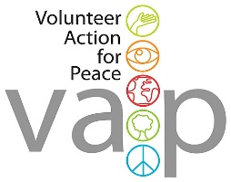

About IVS/VAP
The International Voluntary Service is a peace organisation working for the sustainable development of local and global communities throughout the world. We are a leading charity which has existed since 1931, involving volunteers in international exchanges at home and abroad (international voluntary projects). IVS is the British branch of Service Civil International (SCI), a world-wide network of like-minded branches and partner organisations supporting the mutual exchange of volunteers to work on projects of direct benefit to local communities.
Since 2025 Volunteer Action for Peace merged with IVS and we are now the same charity.

Aims
IVS/VAP aims are:
* To foster peace and understanding between people and nations through voluntary work.
* To provide volunteer help to international projects and organisations working for the benefit of the community.
* To organise international projects and other activities in the UK.

Activities
We deliver a range of activities, the largest of which is coordinating a programme of international voluntary projects in Great Britain which are run in partnership with local voluntary organisations and community groups. A typical short-term project consists of 6 to 15 volunteers from several countries who work and live together for 1 to 3 weeks. Long-term projects last from 1 to 12 months. Projects are diverse, ranging from environmental conservation to supporting refugees or from holiday play schemes for children to working with people with learning difficulties.

