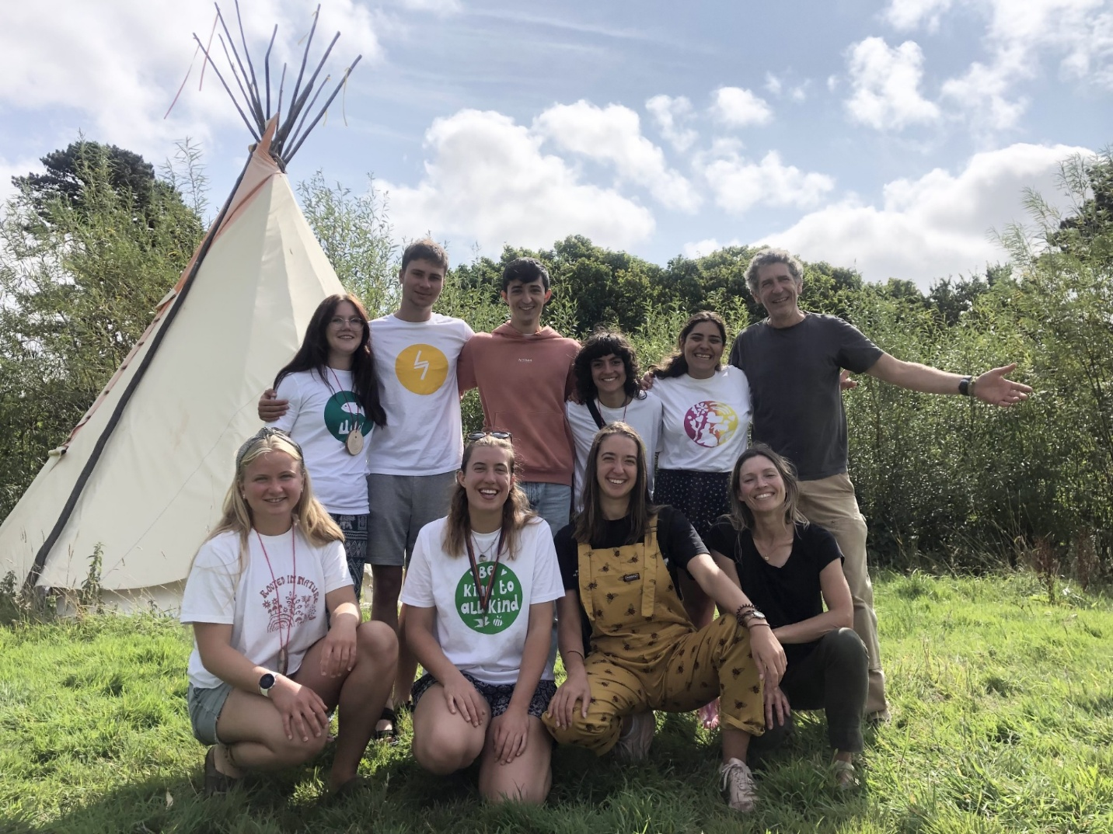

Information Sheet

Camp Kernow:
Environmental Adventure Camp
with children in Cornwall

(PLEASE READ THIS DOCUMENT CAREFULLY!)

Work camp codes and dates:

GB-IVS W7.23 – 16 May to 5 June 2026
GB-IVS W7.24 – 6 June to 3 July 2026
GB-IVS W7.25 – 14 July to 7 August 2026
GB-IVS W7.26 – 8 to 21 August 2026

Responsible person on site during the volunteer stay:
Claire Coombe (Director)

Volunteer profile
Not required but preferred would be an interest in environmental issues and sustainability; previous experience working with children or interest in gaining experience; someone who enjoys being outdoors and active.
What we value most in team members is a positive attitude, enthusiasm and the ability to work well with and inspire others. You need to be able to strike the right balance between being responsible in a pastoral care role and reinforcing rules when required while cultivating a positive and empowering atmosphere in which children can thrive.

Project general description
Camp Kernow is a not-for-profit organisation which operates an award winning and innovative off-grid environmental adventure camp reconnecting children with nature and inspiring sustainability through summer camp experiences.
We're seeking volunteers to join the team as Environmental Adventure Leaders supporting children in a residential summer camp programme which engages them with nature, traditional crafts, environmental issues and adventurous outdoor activities.

As an Environmental Adventure Leader, you can:

-Learn new skills from experienced instructors in Bushcraft, wild food foraging, green woodworking, archery, climbing, canoeing and much more.
-Gain experience and confidence working with children outdoors.
-Live off-grid in bell tents on a beautiful woodland estate overlooking a river in the heart of Cornwall.
-Support children in outdoor activities and help enrich their summer camp experience.
-Make new friends and be part of a dynamic team.
-Spend days off exploring the Cornish coast and try out surfing, SUPing and other exciting activities. There is also the possibility of enjoying a weekend in London if volunteering anytime between 15th July and 22nd August.
-Take part in valuable training, receive references and enhance your CV.

Type of work description
The role is varied and interesting and we strive to give volunteers a rich experience. It includes:

-supporting children during activities providing 1:1 support and encouragement where required.
-assisting instructors with the set up and delivery of activities.
-supervision of children during free time.
-pastoral care of children.
-meeting their emotional needs if they are feeling homesick or anxious or experiencing any issues with their peers.
-harvesting ingredients from the camp’s garden with children and helping them prepare meals in the field kitchen.
-supporting the team with day-to-day maintenance and cleaning tasks.
-depending on your confidence and experience there are opportunities to deliver elements of the activity programme.

You will work a 6-hour shift, usually beginning either at 6:30am, approx. midday or early evening. We ask for 5 days per week.

Free time
Despite being in the middle of nature on a two-hundred-acre woodland estate, camp is within walking distance of Truro city centre. A short walk will take you to the centre of town where you can hop on a bus or jump on a train and be at the beach or another attraction in no time.
Cornwall attracts thousands of tourists from across the world each summer and is renowned for its beautiful beaches and easy-going, outdoor lifestyle. You can try surfing, SUPing, coasteering and lots of other beach-based activities. The river is also on the camp’s doorstep with a network of creeks to explore.
There is also the possibility to travel to London as part of the train escorting team who accompany children to and from camp on the train in July & August. This gives you free London accommodation for two nights and a full day on Saturday to enjoy the city along with a food allowance.

Induction and training
On arrival you will be given a tour of the camp and an orientation to the city of Truro to help you settle in and feel at home. You will receive training in child safeguarding, food hygiene, health & safety alongside more specialist training specific to activities e.g. harvesting & cooking with children, how to assist with activities such as climbing and archery, fire lighting & campfire cooking and much more.

Accommodation, facilities, and food details
Accommodation is tented in bell tents. You would usually share with 1 other volunteer (same sex). Camp beds are provided.

Food and cooking arrangements:
Period between 16th May to 11th July:
You can enjoy three delicious meals a day, Monday to Friday. At the weekend, which are your days off you can help yourself to breakfast and lunch from the camp kitchen. On Saturday and Sunday night volunteers usually cook together and it’s a nice opportunity to have a cultural cuisine exchange! A food kitty is provided.

Period between 15th July to 21st August:
You can enjoy three delicious meals a day, Sunday to Thursday. On Friday we provide breakfast and lunch while dinner can be prepared independently by volunteers with the help of a food kitty to purchase ingredients. On Saturdays which are a free day for all you can help yourself to breakfast and lunch from the camp kitchen. As people are usually off exploring, we don’t provide dinner on Saturday night though if you around you are welcome to use the camp kitchen. Truro City Centre has everything you will need - great transport links, many shops, cafes and restaurants and all the other facilities you may require such as banks, post office etc.

What to bring

Equipment:
Good sleeping bag - clear skies often mean cold nights, even in summer) THIS IS ESSENTIAL
Blanket (if you are coming from overseas, we can lend you one)
Pillowcase (we will provide a pillow but you’re welcome to bring your own)
Towel (ideally the quick drying variety as we do not have drying facilities at camp other than the polytunnel!)
Torch (a head torch is best)
Small daypack/rucksack
Refillable water bottle
Sunglasses
Mobile phone & charger (& adapter for two pins to three)
*please note we do not have sufficient electricity to power a hairdryer!

Toiletries:
The usual plus...
Sunscreen
Insect repellent if you are especially prone to bites!
*Please try to bring toiletries which are natural and kind to the environment as all of the camp’s dirty water from showers and sinks is treated in a reed-bed.

Clothing:
Please bring sufficient clothing for the duration of your stay bearing in mind you will be outdoors, and the Cornish Summer can be unpredictable! Suggested clothing includes:
T-shirts/vests
Sweatshirts/fleeces/jumpers
Trousers/tracksuit bottoms/jeans
Shorts
Sleepwear (the warmer the better - bed socks are also good!)
Swimwear
NB There is a launderette for washing clothes available nearby.

Outer layers:
Warm jacket
Waterproof jacket - ESSENTIAL
Waterproof trousers - ESSENTIAL
Sun hat/cap
Wool hat (for colder evenings)

Footwear:
Walking boots (not essential but useful)
Wellies (if you are already bringing walking boots then wellies are extra rather than essential)
Trainers
Sandals
Old trainers, wet boots or sandals for canoeing

Suggested optional:
Musical instrument if you play one which could be good around the campfire!
Notebook & pen, books
You may want to bring a tablet or laptop. Please note that we cannot accept liability for any lost or stolen items. There is an office building where valuables can be stored securely.

The weather:
Cornish weather is unpredictable. Be prepared for warm, cold, wet and windy weather, sometimes on the same day!

Approximate location and travel tips for volunteers by car, bus, train, and plane
Camp Kernow is located on the edge of Truro which is in the county of Cornwall in the Southwest of England. Truro Train Station is serviced by direct trains from London, Bristol & Exeter and is a 5-minute car journey away.

Newquay Airport is the closest followed by Exeter Airport, then Bristol then London airports.

There are also coaches which travel between London and Truro and are often the cheapest option.

Arrival/departure arrangements
Please liaise with Claire to arrange and confirm your travel dates and times. Generally, we recommend a Saturday departure so volunteers can enjoy a final Friday evening together.

Arrival and departure for camps between 6th June and 3rd July:
Arrival day is ideally Saturday 6th June. It’s also possible to arrive Sunday morning/early afternoon.
Departure is Friday 3rd July afternoon or Saturday 4th July.

Arrival and departure for camps between 14th July and 21st August:
Arrival is Tuesday 14th July in time for volunteer training beginning 15th July
Departure is Friday after 2.30pm or Saturday.

Arrival and departure for camps between 8th August and 21st August:
Arrival is Friday 7th August after 2.30pm or Saturday 8th August (before 6pm to give you time to settle in)
Departure is Friday 21st August after 2:30pm or Saturday 22nd.

What to do in case of earlier arrival/later departure:
Please consult with Claire before booking. Generally, we are unable to host volunteers before the arrival date and time as we have limited accommodation and are unable to do any pick ups on Friday mornings as this is a departure day for summer camp and these mornings are particularly busy with parents collecting and children packing and departing for London.

Will you pick up volunteers from a meeting point? (If so, give details of meeting point):
Yes. We can collect volunteers from Truro Train Station, Bus Station or Newquay Airport provided it is within the times advised above.

Insurance
The SCI scheme provides illness and personal accident insurance cover for the duration of the volunteer project. You will need to take out your own personal belongings and accident insurance as well. Make sure that your medical care is covered. Medical care is not free to visitors from abroad although some countries have reciprocal arrangements with the UK. (For the details of exactly what is covered by the SCI insurance scheme you can contact your sending organisation).
If you have a European Health Insurance Card (EHIC), bring it with you. Make sure it is still valid. The EHIC is not an alternative to travel insurance. It will not cover any private medical healthcare, planned treatment, being flown back home, or lost or stolen property.

Passports and Visa
To enter the UK you will need to show a valid passport. In order to check if you need a visa please visit the UK Government website here: https://www.gov.uk/check-uk-visa/y

IMPORTANT:
All foreign national travelling to the UK need to apply online for an Electronic Travel Authorisation (ETA). You cannot enter the UK without it. Please check the following link on how to apply for it: https://www.gov.uk/guidance/apply-for-an-electronic-travel-authorisation-eta

Additional information
Volunteers need to provide in advance a Police Check from their country stating they have no criminal record.



This project has been organised by the project host with the support of IVS. For any issues you can contact IVS by email to the address provided below or call the number provided below as well – please note our opening hours are 11am to 4pm Monday to Friday. For any emergency out with these hours refer to your project host and/or camp coordinator. In case of serious emergencies call 999.

About IVS
The International Voluntary Service is a peace organisation working for the sustainable development of local and global communities throughout the world. We are a leading charity which has existed since 1931, involving volunteers in international exchanges at home and abroad (international voluntary projects). IVS is the British branch of Service Civil International (SCI), a world-wide network of like-minded branches and partner organisations supporting the mutual exchange of volunteers to work on projects of direct benefit to local communities.
Aims
IVS aims are:
- To foster peace and understanding between people and nations through voluntary work.
- To provide volunteer help to international projects and organisations working for the benefit of the community.
- To organise international projects and other activities in the UK.
Activities
We deliver a range of activities, the largest of which is coordinating a programme of international voluntary projects in Great Britain which are run in partnership with local voluntary organisations and community groups. A typical project consists of 6 to 15 volunteers from several countries who work and live together for 1 to 3 weeks. Projects are diverse, ranging from environmental conservation to supporting refugees or from holiday play schemes for children to working with people with learning difficulties.

International Voluntary Service
Volunteering for Peace and Social Justice
Thorn House, 5 Rose Street, Edinburgh, EH2 2PR
Scotland, UK
Email: info@ivsgb.org
Phone: +44 (0)131 243 2746
www.ivsgb.org
Registered Charity no. 275424 England & Wales;
Charity Registered in Scotland SCO39585;
Company Limited by Guarantee

