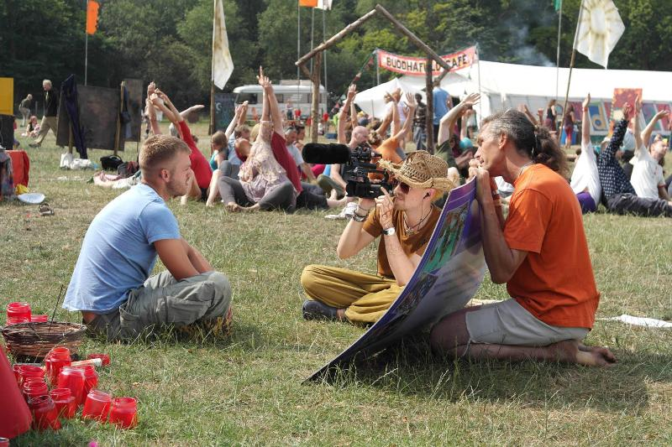
Information Sheet
BUDDHAFIELD FESTIVAL 2026

PLEASE READ THIS DOCUMENT CAREFULLY!

Workcamp code and dates:
GB-IVS W13.5
8 July to 23 July 2026

Dear friend,

You have been confirmed as one of the participants on the Buddhafield Festival 2026 workcamp.
This project has been organised by the project host with the support of IVS/VAP. For any issues you can contact IVS/VAP by email to the addresses provided below or call the number provided below as well – please note our opening hours are 11am to 4pm Monday to Friday. For any emergency out with these hours refer to your project host and/or camp coordinator. In case of serious emergencies call 999.
If you need to email about your attendance or any problems you have in coming or arriving please make sure your email is sent BOTH to:

Nuno Doria at info@ivsgb.org
Buddhafield contact person (email will be sent to you soon)

Thank you,
Nuno Doria
Programme Manager
International Voluntary Service / Volunteer Action for Peace

¤¤¤

Project:
Buddhafield (www.buddhafield.com) is an English Buddhist collective that is part of the international Buddhist movement, the Triratna Buddhist Community (http://thebuddhistcentre.com).

Buddhafield emerged out of the coming together of Buddhism and ecological awareness in the 1990s. Buddhafield is inspired by the ideal of living and working more simply and kindly in a community informed by awareness of our interconnections with each other and with nature. We run a programme of camping activities in the Southwest of England
We are perhaps best known for organising the much-loved Buddhafield Festival.

Work:
Needless to say, for the Festival to be a life-enhancing and indeed for some a life-transforming experience, much hard work is required. From the day we arrive in an empty field with a small group, our numbers gradually increase until we have around eight hundred volunteers welcoming the three thousand visitors.

The set-up crew erect the structures that will act as kitchens and venues. They establish the infrastructure such as plumbing, compost toilets, showers and saunas. They décor team make the site beautiful and safe with flags, bunting, paths, fences and lighting. At the heart of this we have the crew-food team who cook for the volunteers. They provide all set-up crews with 3 beautifully crafted home cooked vegan meals per day.

IVS/VAP volunteers (usually a small group of around 10 internationals) will be invited to work as part of the site-crew, kitchen-crew, decor or recycling teams. They will work for the duration of the set-up and take down and will have the majority of the festival off. Some may need to work short shifts during the festival, depending on what team they are on, but will have plenty of time to enjoy the huge variety of events taking place.
All volunteers including the IVS/VAP ones are asked to attend daily morning meetings, the exact time depending on what area of work they choose to join.

During set-up and take-down, there will be organised events around Buddhist themes, attendance at which is completely voluntary. There are generally also alternatives such as spontaneous musical gatherings, often around a fire. IVS/VAP volunteers will also have someone on site who is their direct contact for support and pastoral care. They will meet as a group together each day.
The work is very team-based. The whole enterprise runs on goodwill, awareness of each other’s needs, good communication and mutual support.

Accommodation, facilities, and food details:
Volunteers sleep in their own tents - see the next section for details of what to bring.
Given we are living and working in a field, the shower and toilet facilities are outdoors and quite basic. There is no electricity or internet/WiFi on site for the duration of your stay at Buddhafield - so please bear this in mind. If you want to use any electrical items/your phone charger you will need to bring a USB battery pack. Also note that the mobile phone signal is unreliable so be prepared to walk up a hill to call home if needed!

Buddhafield will provide 100% vegan food and hot drinks and snacks are available throughout the day. There is no access to shops or supermarkets during the stay so if you want any extra food/animal products, please buy these before you arrive. In doing this, bear in mind that we do not have refrigeration on site.

What to bring:
Buddhafield Festival is in July, when English weather can be very varied. It can range from sunny and very hot to cool and rainy in the daytime. The nights can be mild, but often they are very cold. In order for you to be comfortable in all weathers it is essential that you bring the following clothes and supplies:

Tent (fully waterproof)
Sleeping Bag
Sleeping Mat
Extra blankets (as warm as possible)
Pillow
Waterproof jacket & trousers
Wellington Boots
Warm Socks

Clothes for all weather conditions:
Warm clothes (jumpers, trousers, socks & thermals)
Light clothing for warm days

Toiletries
Suncream
Hat
Earplugs (we highly recommend wax or silicone – some people in tents near you may snore and they cannot help it!)
Torch
Solar Charger/Portable USB charger
Hot Water Bottle

Please also bring everything else you need to be comfortable camping in a field including medicine and sanitary products. We often spend the evenings around the fire, playing music or sharing poetry so we invite you to bring instruments or anything else that you would like to share, too.

Buddhafield is strictly zero alcohol and drugs - please do not bring these. If you smoke tobacco or vape, remember to bring enough for your whole stay.

Location and travel tips:

Arriving in the UK:
From London St. Pancras (Eurostar arrival station), Victoria Coach Station (Eurolines arrival station) or other London airports, make your way to Paddington train station for trains to Taunton. The quickest way to get there is by tube; https://content.tfl.gov.uk/standard-tube-map.pdf Allow plenty of time!

From London Heathrow airport take the rail connecting bus to Reading then a train to Taunton https://thetrainline.com

There are direct flights to Bristol airport from many cities in Europe.
https://www.bristolairport.co.uk/where-can-i-fly/explore-destinations

There is a bus to Bristol Temple Meads train station, or you can take a Megabus www.ukmegabus.com from Bristol airport to Taunton (in 1,5 hours with one change).

Train:
The nearest train station is Taunton. Journeys take about 2 hours from London or 1 hour from Bristol. The latest trains to get you to Taunton in time for the pickup at 5pm are from London Paddington at 13:03, 14:03, 14:36, from Bristol Temple Meads at 14:45, 14:55 or 15:45. To buy cheap tickets for the above trains in advance go to www.thetrainline.com

Coach (Bus):
Megabus leaves Bristol Airport at 13:55 and 15:10 (1,5 hour journey with one change)
To book go to www.megabus.co.uk

Local taxis:
In case you cannot be at the meeting point, the best way to get from Taunton to the festival site is by Taxi. Some local taxi companies are as follows; Taunton Taxi Services 01823 248248; Ace Taxis 01823332211; Leo Taxis 01823 924400 or Charlie Cabs 01823 353535. We recommend you pre-book.

General UK travel information can be found on:
www.traveline.info
www.travelinesw.com

ARRIVAL:
MEETING POINT: A member of the Buddhafield team will meet people at a local coffee shop called Coffee#1 close to the train station and help them get to the site. If you want to travel with a team member it is important that you arrive at Taunton train station by 4:30 on Wednesday 8 July to allow enough time to get to the coffee shop. We will leave for site at 5pm. If you have heavy bags or need help getting to the cafe please call the Buddhafield contact person (we will send you the name of contact details by email in a few days).

DEPARTURE:
The leaving day for international volunteers will be Thursday 23 July. If you could try and arrange your travel from Taunton after 11am that would enable us to take you to the bus or train station.

Insurance:
You are strongly advised to take out your own personal insurance policy so that you are covered on your journey and for your time in the UK before and after the workcamp and for loss of baggage.

Visa and Electronic Travel Authorisation (ETA):
To enter the UK you will need to show a valid passport. To check if you need a visa please visit the UK Government website here: https://www.gov.uk/check-uk-visa/y

NB: All foreign nationals travelling to the UK need to apply online for an Electronic Travel Authorisation (ETA). Your volunteer cannot enter the UK without it. Please check the following link on how to apply for it: https://www.gov.uk/guidance/apply-for-an-electronic-travel-authorisation-eta

Additional information:
Volunteers need to provide in advance a Police Check from their country stating they have no criminal record.

¤¤¤


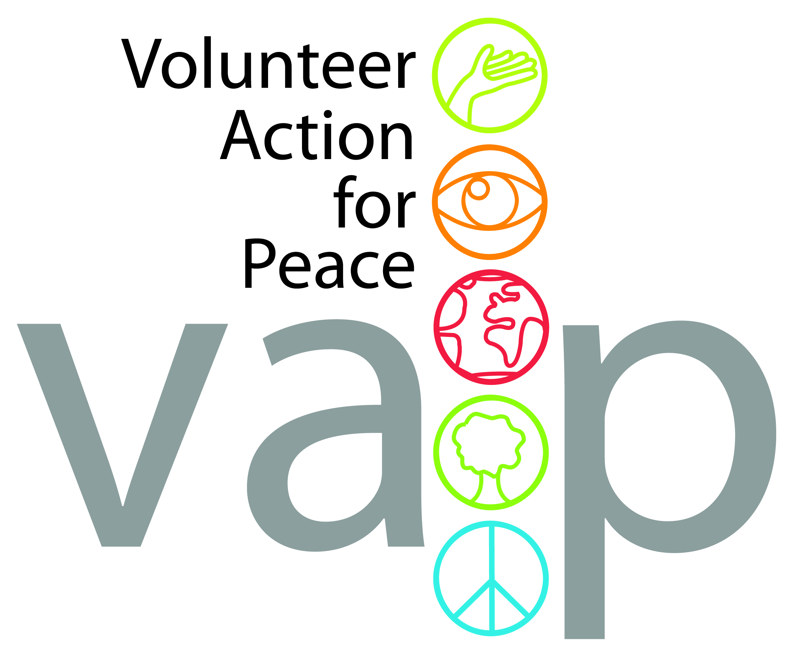

Hosting Organisation:

International Voluntary Service / Volunteer Action for Peace

Volunteering for Peace and Social Justice

Thorn House, 5 Rose Street, Edinburgh, EH2 2PR
Scotland, UK
Email: info@ivsgb.org
Phone: +44 (0)131 243 2746
www.ivsgb.org
Registered Charity no. 275424 England & Wales;
Charity Registered in Scotland SCO39585;
Company Limited by Guarantee
Contact person: Nuno Doria, Programme Manager

Hosting Project:

Buddhafield Festival
Taunton, Somerset, UK
http://www.buddhafield.com/

*****

About IVS/VAP
The International Voluntary Service is a peace organisation working for the sustainable development of local and global communities throughout the world. We are a leading charity which has existed since 1931, involving volunteers in international exchanges at home and abroad (international voluntary projects). IVS is the British branch of Service Civil International (SCI), a world-wide network of like-minded branches and partner organisations supporting the mutual exchange of volunteers to work on projects of direct benefit to local communities.
Since 2025 Volunteer Action for Peace merged with IVS and we are now the same charity.

Aims
IVS/VAP aims are:
- To foster peace and understanding between people and nations through voluntary work.
- To provide volunteer help to international projects and organisations working for the benefit of the community.
- To organise international projects and other activities in the UK.

Activities
We deliver a range of activities, the largest of which is coordinating a programme of international voluntary projects in Great Britain which are run in partnership with local voluntary organisations and community groups. A typical short-term project consists of 6 to 15 volunteers from several countries who work and live together for 1 to 3 weeks. Projects are diverse, ranging from environmental conservation to supporting refugees or from holiday play schemes for children to working with people with learning difficulties.

